Class 3

## 2.1 Eigenvalues and Eigenvectors

### 2.1.1Basis change



**Definition**

A matrix A is similar to a matrix A’ if there is an invertible matrix P, such that

|  |  |
| --- | --- |
|  |  |
|  |  |
|  | |

Consider the matrix A and the matrix P (sse class 3)

,

## 2.1.2 Introduction and definitions

Determine



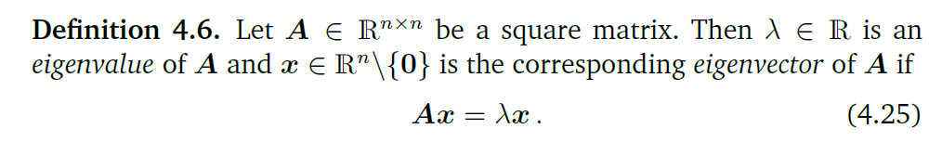

* If is eigenvector associated with then is also eigenvector associated with.



* If are linearly independent eigenvectors associated with then is also eigenvector associated with k.



* There can be linearly independent eigenvectors associated with the same eigenvalue.
* The scalar 0 can be an endomorphism's eigenvalue. In this case, any eigenvector associated with 0 belong to the kernel, therefore, the endomorphism cannot be injective.

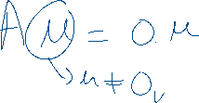

## 2.1.3 Eigenvalues and Spectrum



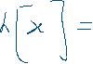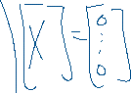

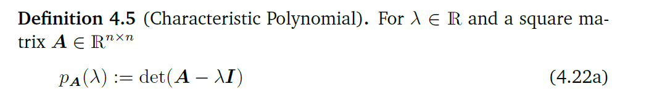 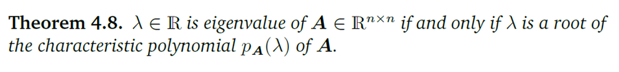

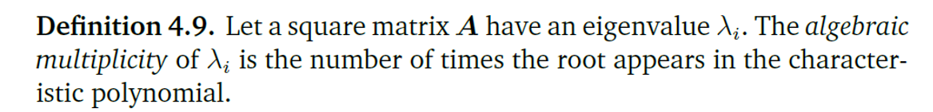

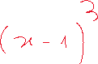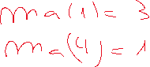

## 2.1.4 Eigenvectors and eigenspace

Suppose that is a eigenvector associate to the eigenvalue , then





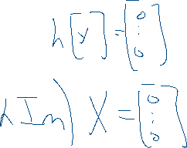

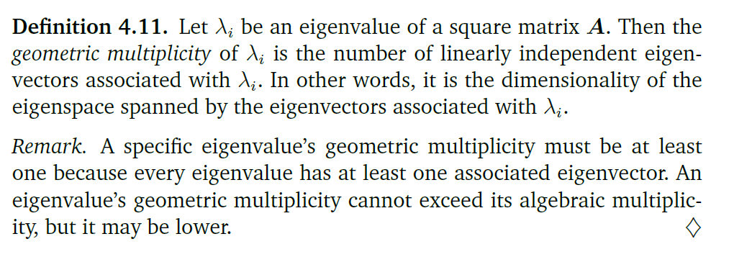



*Graphical Intuition in Two Dimensions*

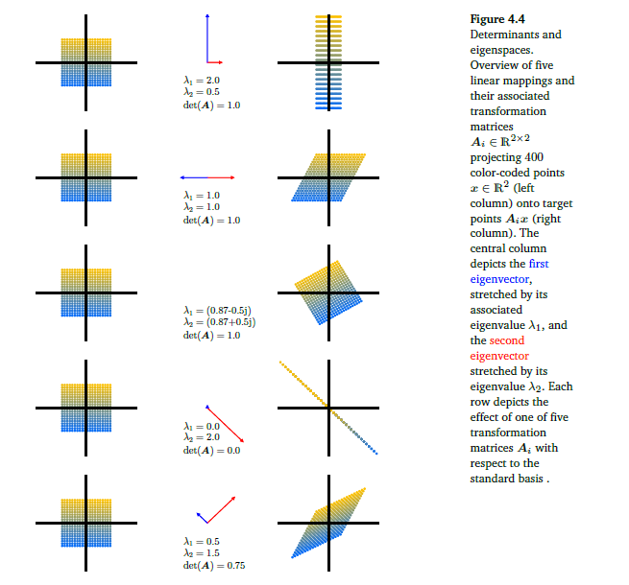

***Exercise***

Consider the transformation matrices: (class 3)

Without resorting to maple commands "eigenvalue" and “eigenvector”

1. Determine the characteristic polynomial and its eigen spectrum.
2. Determine the eigenvectors and eigenspaces.

## 2.2 Eigendecomposition and Diagonalization

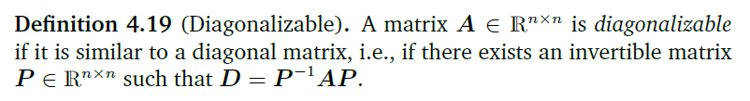



|  |  |
| --- | --- |
|  |  |
|  |  |











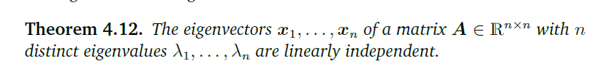

**Theorem**

The eigenvectors of a matrix form a basis of if and only if for

distinct eigenvalues 1, 2, ...., k , we have:



***Example (class 3)***

Consider the transformation matrices:

and 

Without resorting to maple commands "eigenvalue" and “eigenvector”

1. Compute the eigenspaces of the above transformation matrices.
2. Verify if they are diagonalizable?
3. In affirmative case, find the eigen decomposition .
4. For each eigenvector of B, calculate .

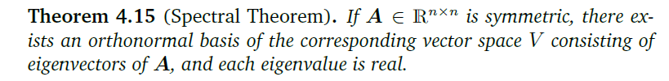

**



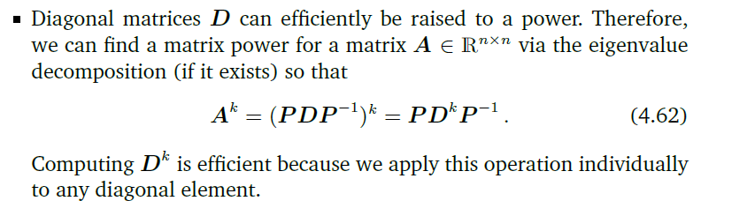

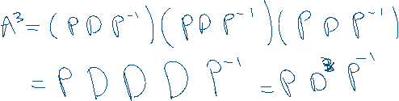

# 2.4 Applications

## 2.4.1 Populational Growth (Poole)

We intend to study the growth evolution of a certain animal species, whose maximum age of a female is 3 years, and that the population can be divided into three age groups: young (up to 1 year); young adults (from 1 to 2 years); adults (from 2 to 3 years).

It is known that in each year the young do not reproduce, the young adults produce 3 offspring and the adults only one.

It is also known that, the probability of a young reaching young adult is 60%, while the probability of a young adult reaching adult is 40%.

If a population has j young individuals, young adult individuals, and adult individuals. What will be the predicted number of adults after one year, two years, and 10 years?

After a year the number of individuals can be estimated by:



* young individuals will be ______________



* young adult individuals will be ___________



* adult individuals will be ___________



In matrix terms these calculations can be represented by:





* the first year will be



* the second year will be



* the third year will be



…



* i-ésimo year will be



The matrix L is called the Leslie matrix, and is used in biology to estimate population growth with n age classes of equal length. In general, the Leslie matrix is defined by





Where is the average number of females produced by the class and is the probability that a female in the class survives (i.e. in the next stage is in the class ). The population distribution at the end of the year will be calculated by 

**Example:** In an initial population of 40 youth, 30 young adults, and 20 adults, determine the distribution of the population after 150 years

1. Determine the number of individuals after 150 years.
2. Determine the ratio for each adult
3. Determine the growth rate
4. Determine the eigenvalues and eigenvectors of L

## 2.4.2 Population Predictions (Williams)

A village with a population of 4725 people has two supermarkets: In the current month 2300 of its residents usually go to supermarket A, and the remaining 2425 are customers of supermarket B. The probability that at the end of each month, a customer from supermarket A will switch to supermarket B is 10%, while 85% of the customers of supermarket B, do not change their preferences.

The Markov Matrix

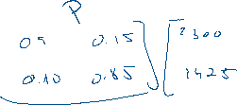

* at the end of the first month of



* at the end of the second month of



* at the end of the i-ésimo month of



**Example:** Determine the market evolution after 100 months

1. Determine the market evolution after 100 months
2. Determine the market evolution after 101 months
3. Determine the eigenvalues and eigenvectors of P
4. Determine

## 2.4.3 Ranking sports teams (Poole)

After 6 games in a snooker championship with 4 players, the results were recorded in a matrix A, as follows:  if the player win to player  and has otherwise.







* indicates that player i is ranked more highly than player j.
* For is  , for all I and 



The ranking of each player is intended to be proportional to the sum of the rankings of the players defeated by player i. Let  be the constant of proportionality:

|  |  |
| --- | --- |
|  |  |
|  |
|  |
|  |

Observe that we can write this system in matrix form as



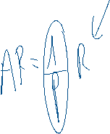

* Determine the eigenvalues and eigenvectors
* Determine an eigenvector such that such that .